Psychological First Aid for COVID-19 Frontline Workers in AI/AN Communities
Social Media Toolkit

FACEBOOK POST

NEW free resource: We are proud to announce the release of Psychological First Aid for COVID-19 Frontline Workers in AI/AN Communities! This release includes a culturally adapted online training and guide intended to promote mental health and resilience among Indigenous communities. These resources teach skills to support healthy coping, responding to serious distress, providing supportive communication, and more.

Access the free guide and online training here: bit.ly/PsychFirstAid4COVID19

#Indigenous #MentalHealth #COVID19 #NativeWellness #IndigenousWellness

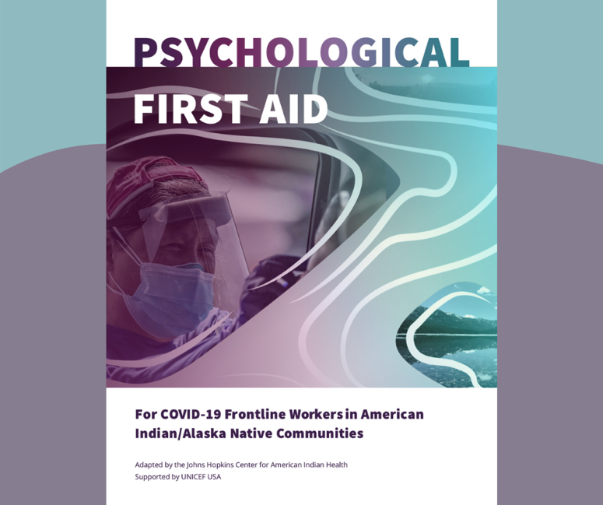

INSTAGRAM POST

NEW free resource: We are proud to announce the release of Psychological First Aid for COVID-19 Frontline Workers in AI/AN Communities! This release includes a culturally adapted online training and guide intended to promote mental health and resilience among Indigenous communities. These resources teach skills to support healthy coping, responding to serious distress, providing supportive communication, and more.
Access the free guide and online training here: bit.ly/PsychFirstAid4COVID19

#Indigenous #MentalHealth #COVID19 #NativeWellness #IndigenousWellness

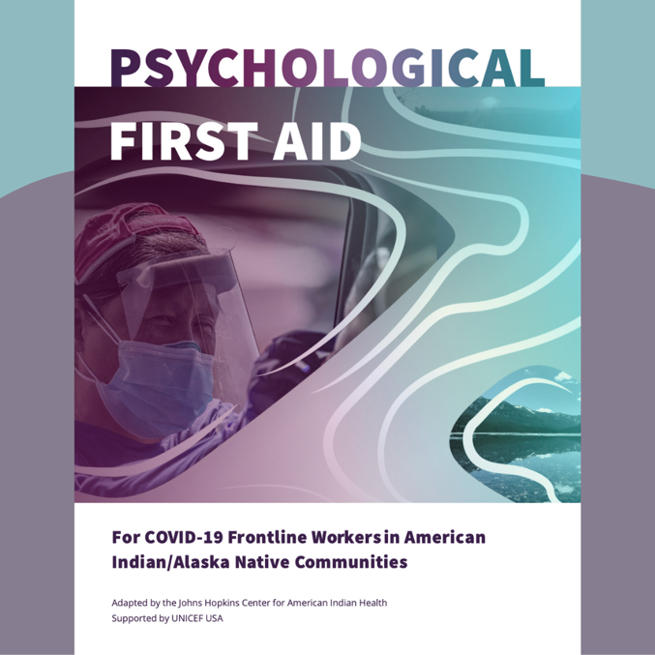

TWITTER POST

NEW free resource: Psychological First Aid for COVID-19 Frontline Workers in AI/AN Communities! This culturally adapted online training and guide promote mental health and resilience among Indigenous communities.

Access these resources here: bit.ly/PsychFirstAid4COVID19

#MentalHealth #COVID19 #IndigenousWellness
